REPORT

TASK 1

# Task 1

Output screenshot

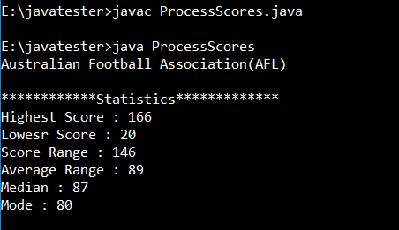

Logic Explanation

* Here I have created a ProcessScores class
* In that class given text file is read and stored in array
* Then required static method are created which are
  + Highest
  + Lowest
  + Average
  + Range
  + Median
  + Mode
* In main method all the methods are invoked to display the statistics for the Australian Football Association(AFL).